**Azure fundamental assignment 4**

1. **List Features and benefits of ExpressRoute.**

ExpressRoute lets you extend your on-premises networks into the Microsoft cloud over a private connection with the help of a connectivity provider. With ExpressRoute, you can establish connections to Microsoft cloud services, such as Microsoft Azure and Microsoft 365.

**Features**:

* Private connections to Azure
* Increased reliability and speed
* Lower latency
* Supports bandwidth up to 100 Gbps
* Connects directly to your WAN
* Connect your on-premises networks using the Microsoft global network
* Support for IPv6 workloads
* Physical link encryption with MACsec

**Azure ExpressRoute Benefits**

* Integrate with Azure for a true Public/Private Hybrid solution.
* Private connections to Azure environment.
* Increased reliability and speed.
* Unified connectivity to all Microsoft Cloud Services.
* Lower latency and higher security.
* Reduce costs by taking advantage of lower transfer rates.

1. **Explain Azure storage account, disc storage and blob storage.**

An **Azure Storage Account** is a secure account, which provides you access to services in Azure Storage. The storage account is like an administrative container, and within that, we can have several services like blobs, files, queues, tables, disks, etc. And when we create a storage account in Azure, we will get the unique namespace for our storage resources. That unique namespace forms the part of the URL. The storage account name should be unique across all existing storage account name in Azure.

# Azure Disk Storage

VM uses disks as a place to store an operating system, applications, and data in Azure. All virtual machines have at least two disks- a Windows operating system disk and a temporary disk. Both the operating system disk and the image are virtual hard disks (VHDs) stored in an Azure storage account. The VHDs used in Azure is .vhd files stored as page blobs in a standard or premium storage account in Azure. Virtual machines can also have one or more data disks that are also stored as VHDs.

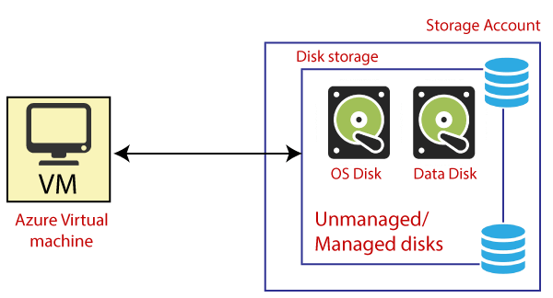

**Temporary Disk:** It is associated with the virtual machine that will be located in the underlying hardware from where the server is provisioned. So, the temporary disk will not be stored in a storage account. It will be stored in the underlying hardware from where this server is located.

## Types of Disk

Different kinds of disks that are offered by Azure:

**Unmanaged disks:** It is a traditional type of disk that has been used by VMs. With these disks, we can create our storage account and specify that storage account when we create the disk. We must not put too many disks in the same storage account, resulting in the VMs being throttled.

**Managed disks:** It handles the storage account creation/management in the background for us and ensures that we do not have to worry about the scalability limits of the storage account. We specify the disk size and the performance tier (standard/premium), and Azure creates and manages the disk for us.

* **Standard HDD disks:** It delivers cost-effective storage. It can be replicated locally in one data-center, or be geo-redundant with primary and secondary data centers.
* **Standard SDD disks:** It is designed to address the same kind of workloads as standard HDD disks, but offer more consistent performance and reliability than HDD. It is suitable for applications like web servers that do not need high IOPS on disks.
* **Premium SSD disks:** It is backed by SSDs, and delivers high-performance, low-latency disk support for VMs running I/O-intensive workloads. The premium SSD disks are mainly used for production and database servers. So if we are hosting a database in a particular server, then the premium SSD will be a good option.

Microsoft recommends that we should use managed disks for all new VMs and convert our previous unmanaged to managed disks.

# Azure blob storage

It is Microsoft's object storage solution for the cloud. Blob storage is optimized for storing a massive amount of unstructured data, such as text or binary data.

**Blob storage usages:**

* It serves images or documents directly to a browser.
* It stores files for distributed access.
* We can stream video and audio using blob storage.
* Easy writing to log files.
* It stores the data for backup, restore, disaster recovery, and archiving.
* It stores the data for analysis by an on-premises or Azure-hosted service.

Azure blob storage is fundamental for the entire Microsoft Azure because many other Azure services will store the data within a storage account, inside the blob storage, and act upon that data. And every blob should be stored in a container.

1. **List and describe database services that are available on Microsoft Azure.**

**Service Description**

Azure Cosmos DB NoSQL database. Globally distributed.

Azure SQL Database Relational database

Azure Database for MySQL Fully managed MySQL database

Azure Database for PostgreSQL Fully managed PostgreSQL database

Azure Database Migration Service Migrate databases to the cloud

Azure Cache for Redis Managed service for Redis

1. **What is the Azure security center?**

Microsoft Azure Security Center is a set of tools for monitoring and managing the security of virtual machines and other cloud computing resources within the Microsoft Azure public cloud. Administrators access the Azure Security Center **through the Azure management portal**.

1. **How to detect and respond to security in Azure.**

Microsoft Defender for Cloud is a solution for cloud security posture management (CSPM) and cloud workload protection (CWP) that finds weak spots across your cloud configuration, helps strengthen the overall security posture of your environment, and can protect workloads across multicloud and hybrid environments from evolving threats.

Azure Defender for advanced features Just in time VM Access, Regulatory Compliance Dashboard, Threat protection for VMs and PaaS services.

1. **What is the Azure key vault? Write its features and advantages.**

Azure Key Vault is a cloud service for securely storing and accessing secrets. A secret is anything that you want to tightly control access to, such as API keys, passwords, certificates, or cryptographic keys. Key Vault service supports two types of containers: vaults and managed hardware security module(HSM) pools. Vaults support storing software and HSM-backed keys, secrets, and certificates. Managed HSM pools only support HSM-backed keys.

**Features:**

* Increase security and control over keys and passwords
* Create and import encryption keys in minutes
* Applications have no direct access to keys
* Use FIPS 140-2 Level 2 and Level 3 validated HSMs
* Reduce latency with cloud scale and global redundancy
* Simplify and automate tasks for SSL/TLS certificates

**Advantages**:

**Provision new vaults and keys (or import keys from your own HSMs) in minutes and centrally manage keys, secrets and policies**. You keep control over your keys—simply grant permission for your own and partner applications to use them as needed. Applications never have direct access to keys.